Athletic Field Athletic Field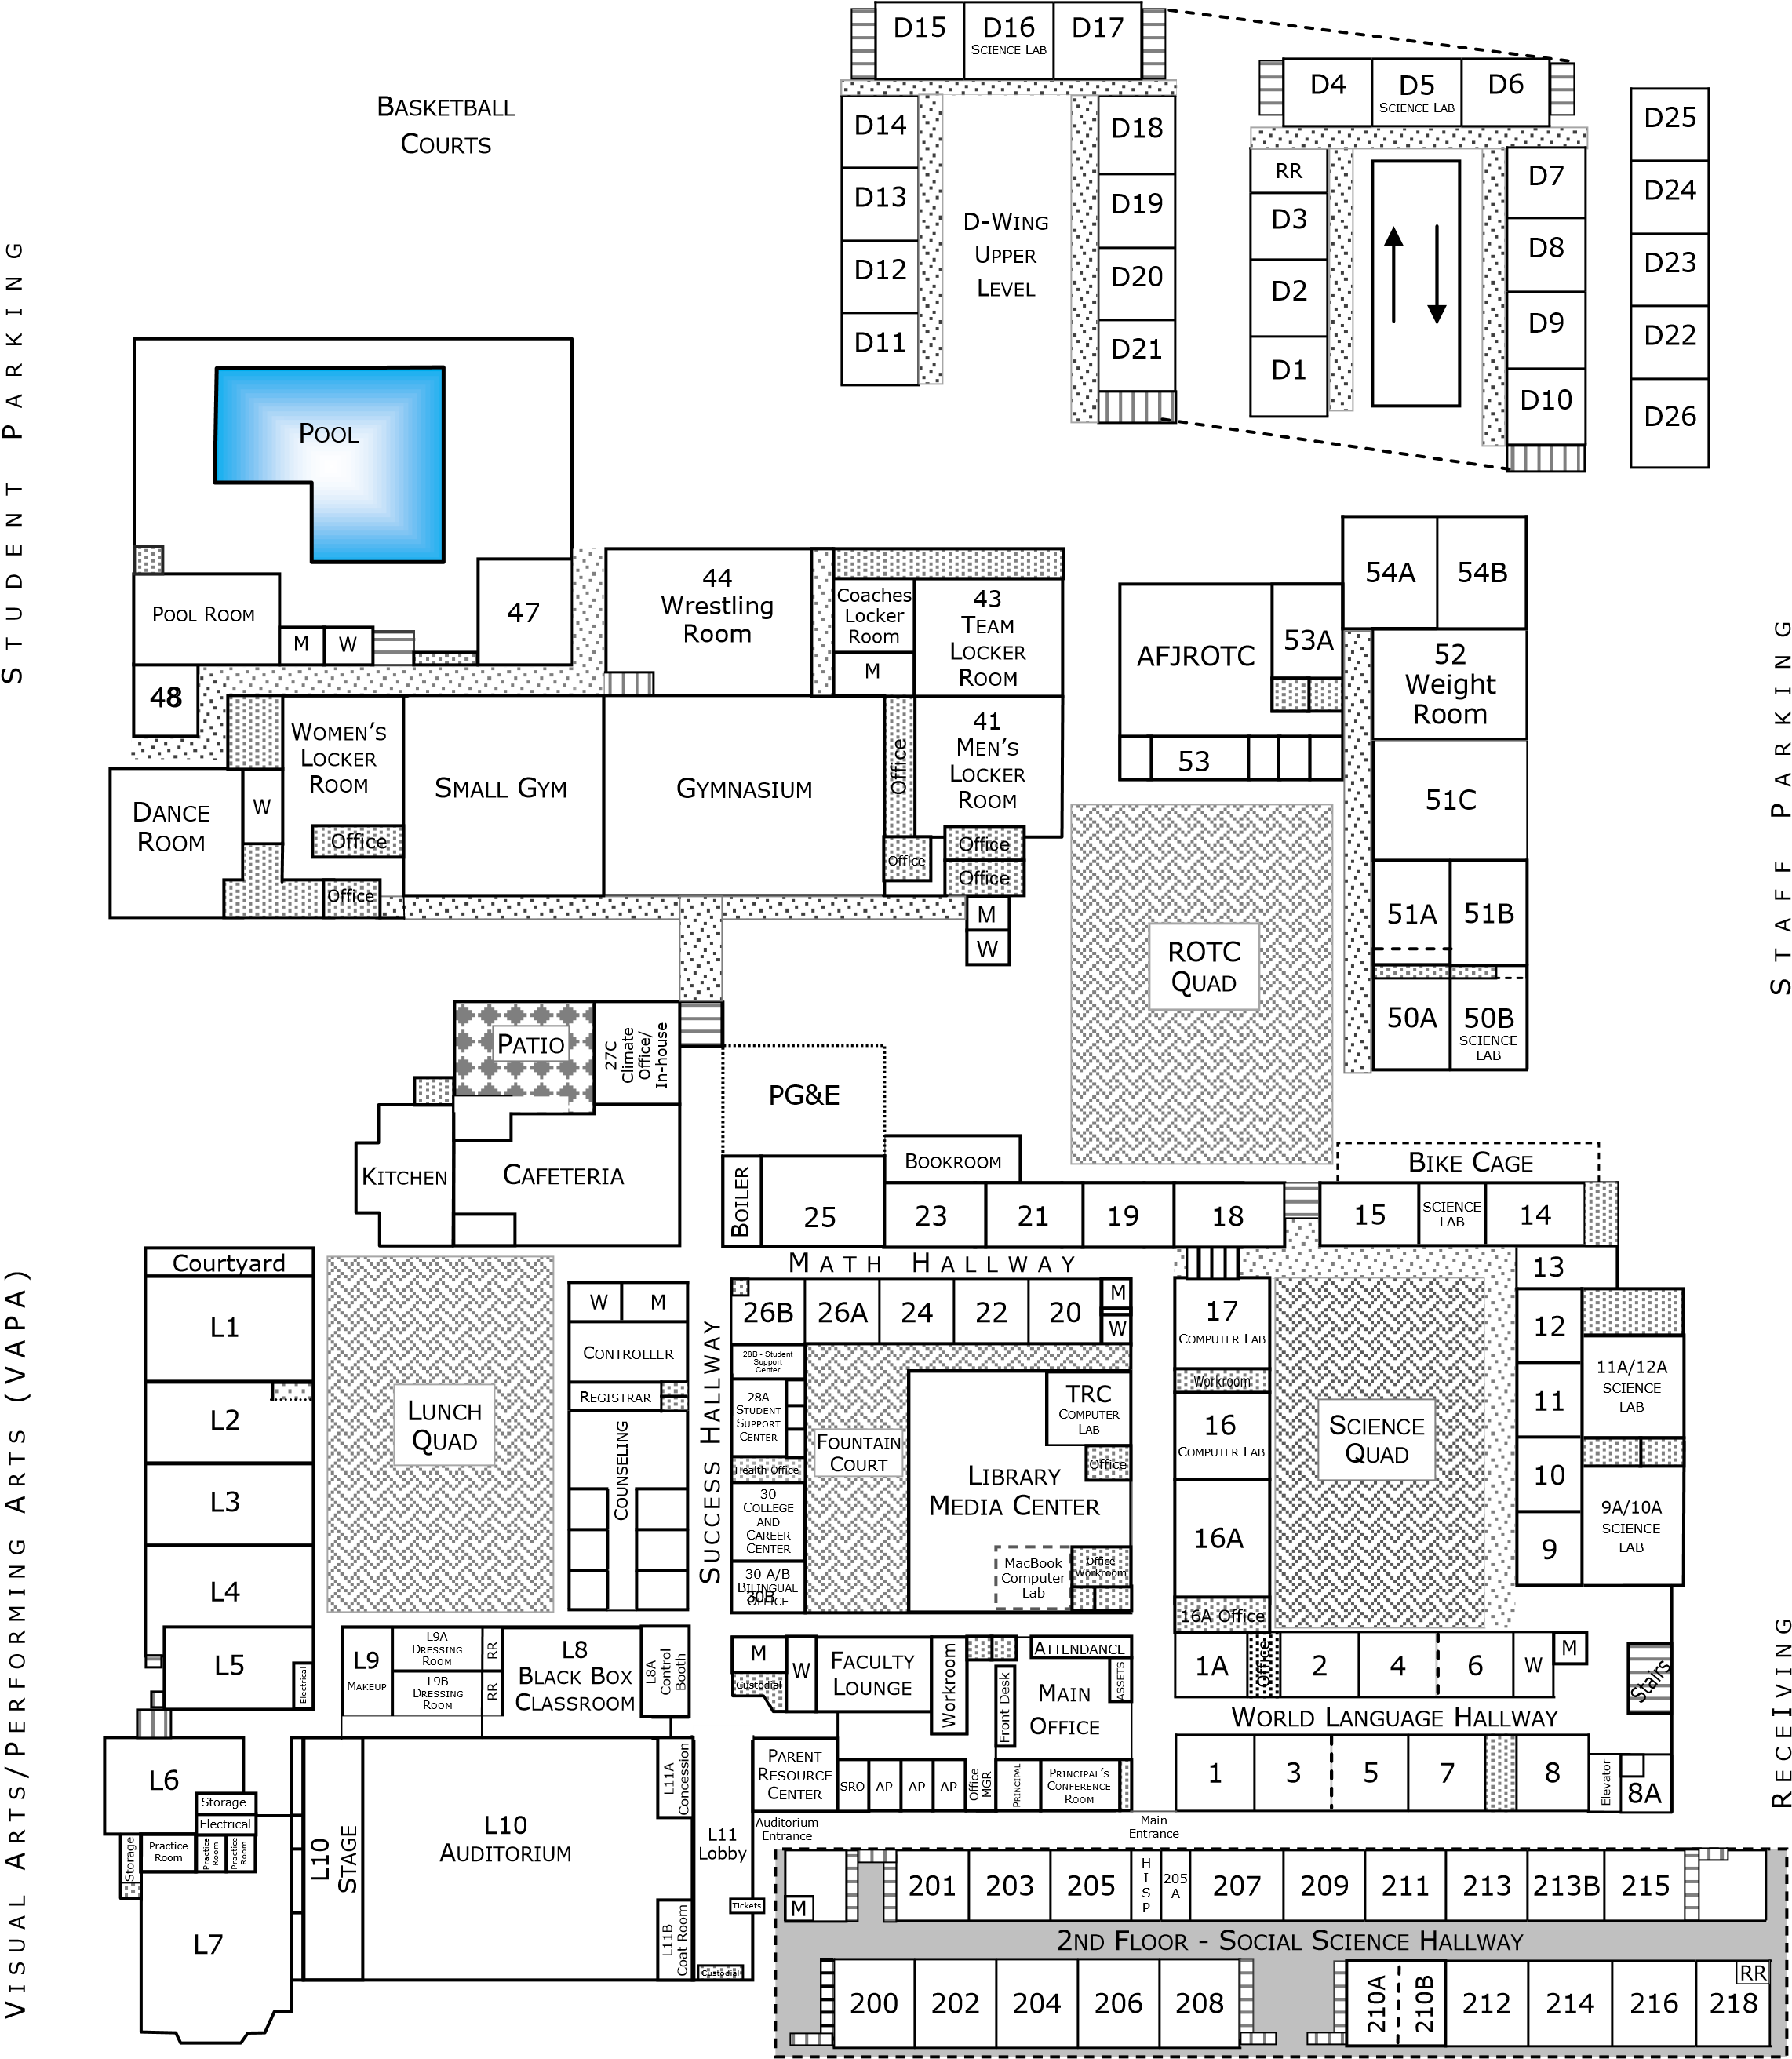
W
M

Gymnasium

Visitor Parking
28 - College & Career Center

Revised 8/9/2017

